NAME : GOWTHAM S
ROLL NO : 24BAD028
EXPT NO:3 | CLEANSE DATA BY HANDLING MISSING VALUES, OUTLIERS, AND INCONSISTENCIES USING TABLEAU AND POWERBI
DATE: 10.07.2026

PRE-LAB QUESTIONS

- What are the potential impacts of missing values in a dataset, and what are some common strategies to address them in Tableau and Power BI?
Missing values reduce data accuracy and may produce misleading results. Tableau and Power BI handle them by filtering, replacing null values, using calculated fields, or removing incomplete records.

- What is the importance of identifying and addressing outliers in a dataset? How can outliers affect data analysis and model performance?

Outliers can distort trends, averages, and model accuracy. Identifying and treating them improves data quality, visualization reliability, and the performance of analytical and predictive models.

- What types of data inconsistencies might you encounter during data cleansing, and how can Tableau and Power BI help in resolving them?

Common inconsistencies include duplicate records, incorrect formats, inconsistent names, and missing values. Tableau and Power BI provide filtering, transformations, calculated fields, and data profiling tools to resolve them.

- How do you identify patterns in data using visualizations to spot missing values, outliers, and inconsistencies?

Visualizations such as scatter plots, box plots, histograms, and heatmaps help identify missing values, detect outliers, recognize unusual patterns, and reveal inconsistencies in datasets.

- What is the role of calculated fields in data cleansing, and how can they be used to handle missing values and outliers in Tableau/Power BI?

Calculated fields create new values using formulas. They replace null values, standardize data, calculate averages, flag outliers, and improve data consistency for accurate analysis and visualization.

IN-LAB EXERCISE:
OBJECTIVE:
To clean a given dataset (e.g., Superstore Sample in Tableau and Financials/Sales Data in Power BI) by identifying and resolving missing values, outliers, and inconsistencies using built-in tools, ensuring the dataset is accurate and ready for analysis.
PROCEDURE:
  - Open the Tool and Connect Dataset
o Open Tableau Desktop , Power BI Desktop.
    - Load the built-in dataset (Sample - Superstore in Tableau / Financials in Power BI).
    - Preview the dataset to understand its structure.

  - Initial Inspection
o Explore fields such as Sales, Profit, Region, or Product Category.
    - Check for nulls, inconsistent text values (e.g., "South Region" vs. "South"), or date formatting issues.

  - Handling Missing Values
o Use Data Interpreter (Tableau) / Power Query (Power BI) to highlight nulls.
o Replace missing numerical values with mean/median, and text with " Unknown".
    - Use calculated fields: IFNULL([Field], Default) in Tableau or IF(ISBLANK([Field]), "Unknown", [Field]) in Power BI.

  - Detecting and Managing Outliers
o Create scatter or box plots for Sales and Profit to identify extreme values.
    - Choose strategies:
      - Filter them temporarily.
      - Apply caps using calculated columns.
      - Flag them with labels for review.

  - Resolving Inconsistencies
o Use Group/Alias (Tableau) / Replace Values (Power BI) to standardize text.
    - Normalize data formats, such as date fields or currency units.
- Validation with Visuals
    - Build dashboards with histograms, bar charts, and box plots to visually confirm improvements.
    - Compare before/after cleaning stages for accuracy.

- Save the Cleaned Dataset
o Save as .twbx (Tableau) / .pbix (Power BI).
o Optionally export cleaned data to .csv.
- Summary Dashboard
o Create a visual summary of the cleaning process, highlighting:
      - Fields corrected.
      - Nulls/outliers removed or adjusted.
      - Clean dataset metrics (record count, completeness %).

Experiment Dataset:
  - Tableau: Sample - Superstore
  - Power BI: Financials or Sales Data
How to Access:
Tableau:
  - Navigate to: Start Page → Sample Workbooks
  - Or: Help → Sample Data → Open Sample Data Folder
Power BI:
  - Navigate to: Home → Get Data → Excel → Choose sample datasets (e.g., Financial Sample.xlsx)
  - Microsoft also hosts Power BI sample datasets online.
Fields Used:
  - Sales
  - Profit
  - Region
  - Category
  - Order Date / Transaction Date

Using Tableau :

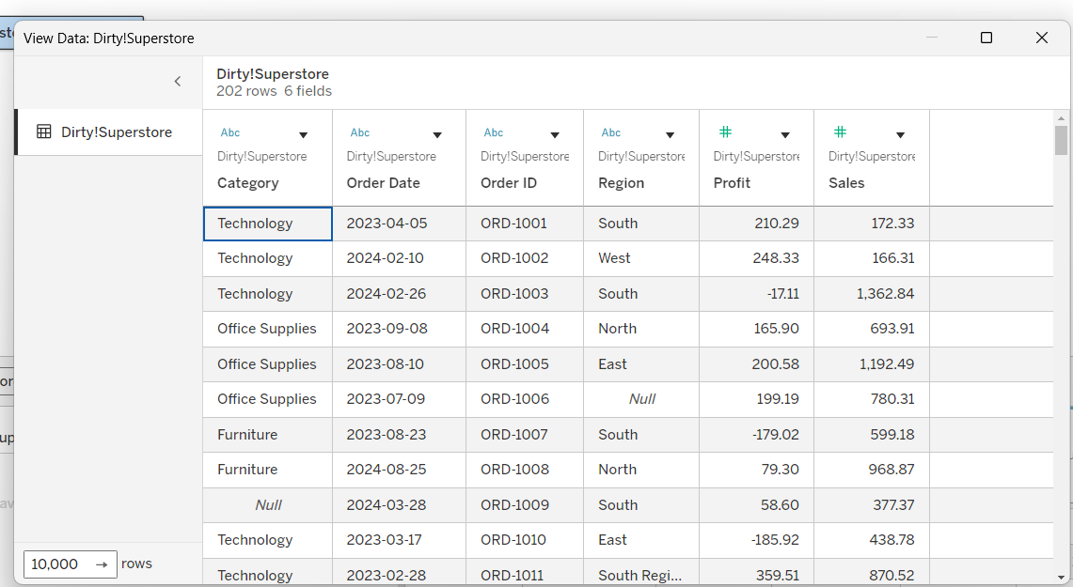
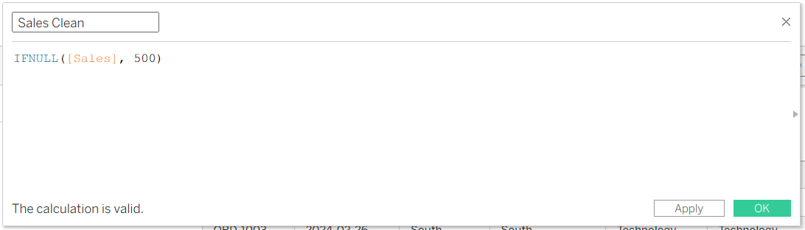
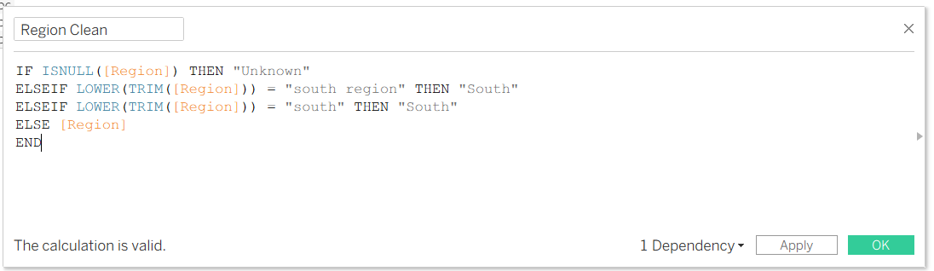
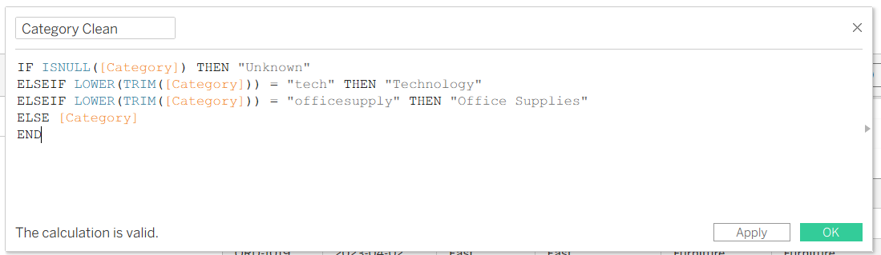
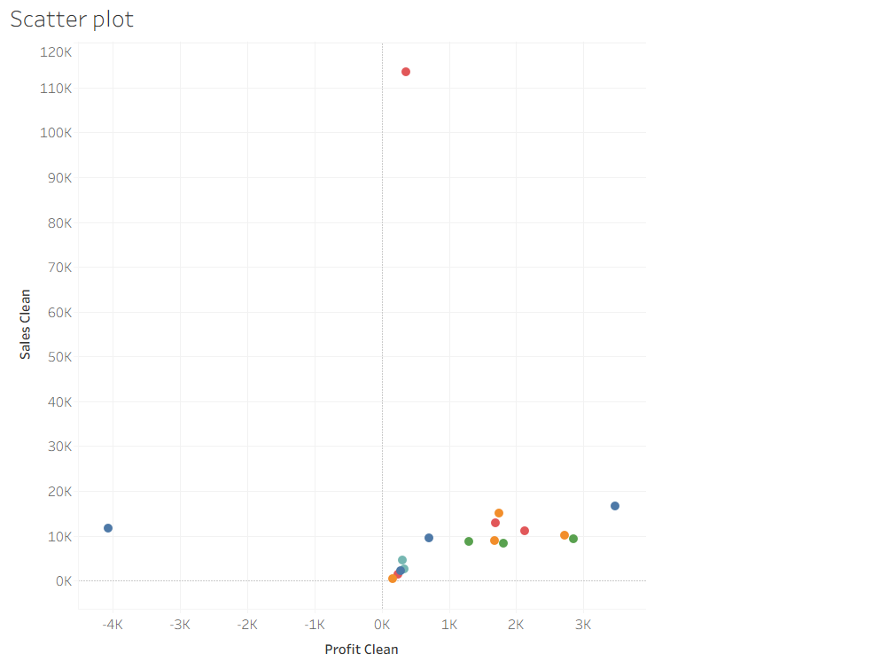

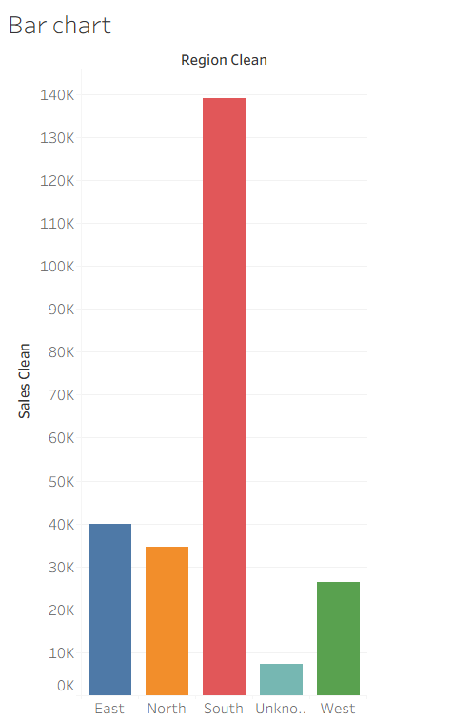
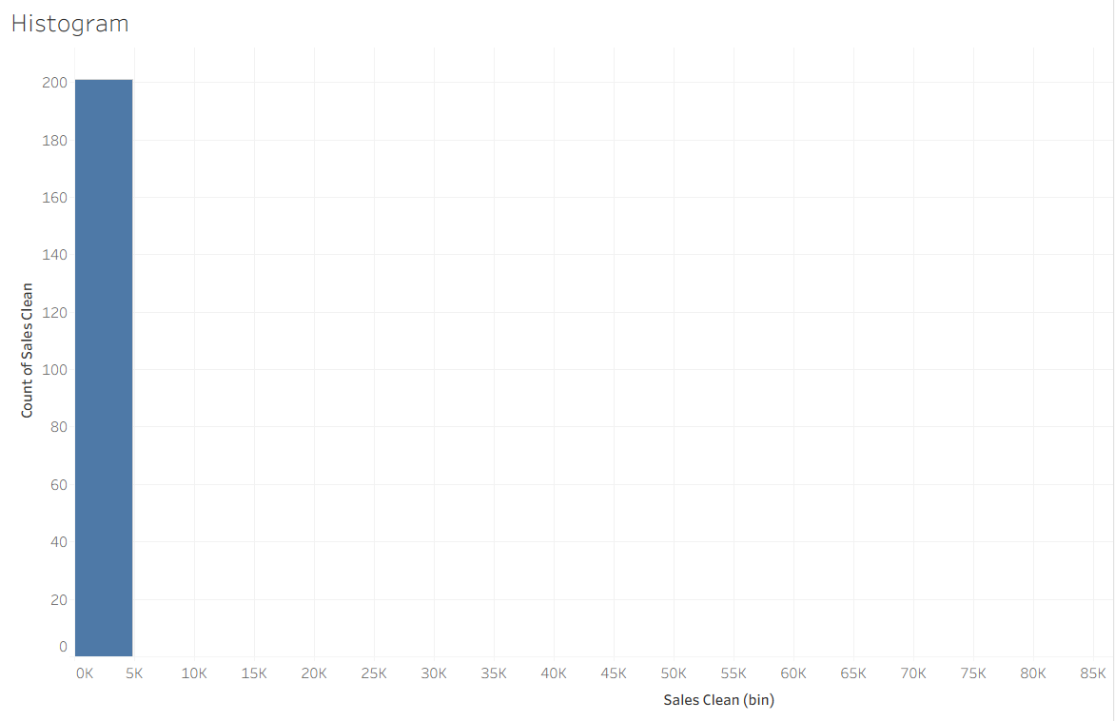
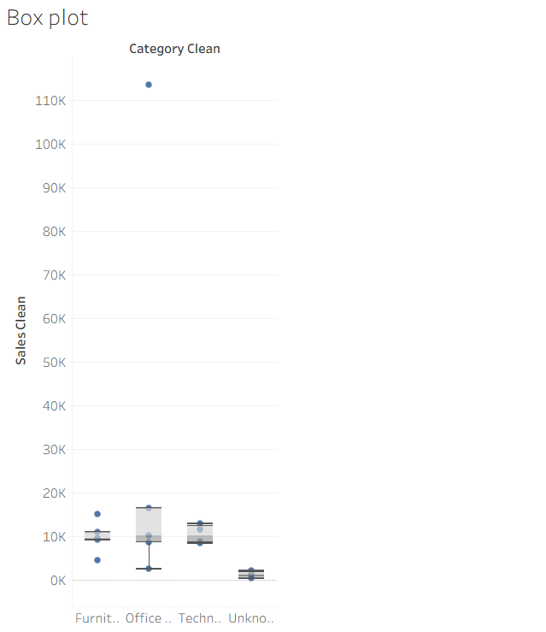
Dashboard :
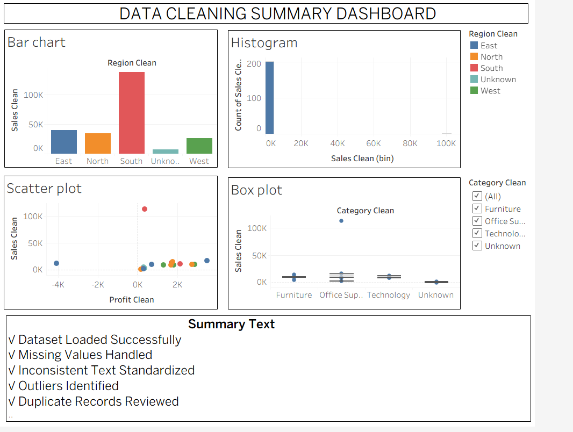

Using PowerBI :
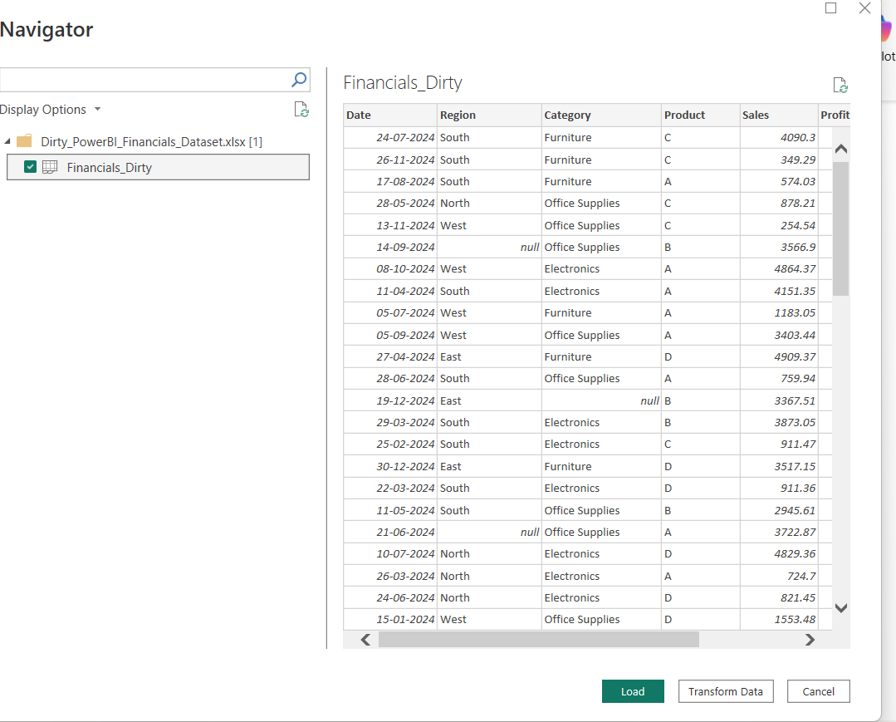
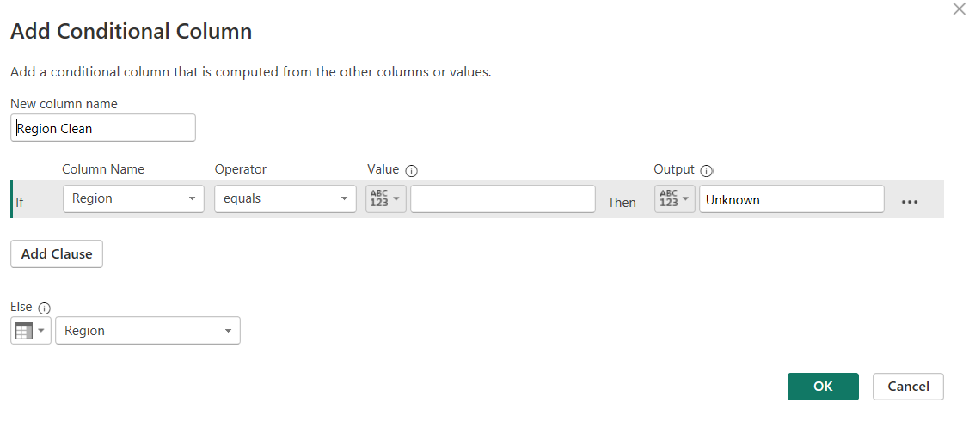
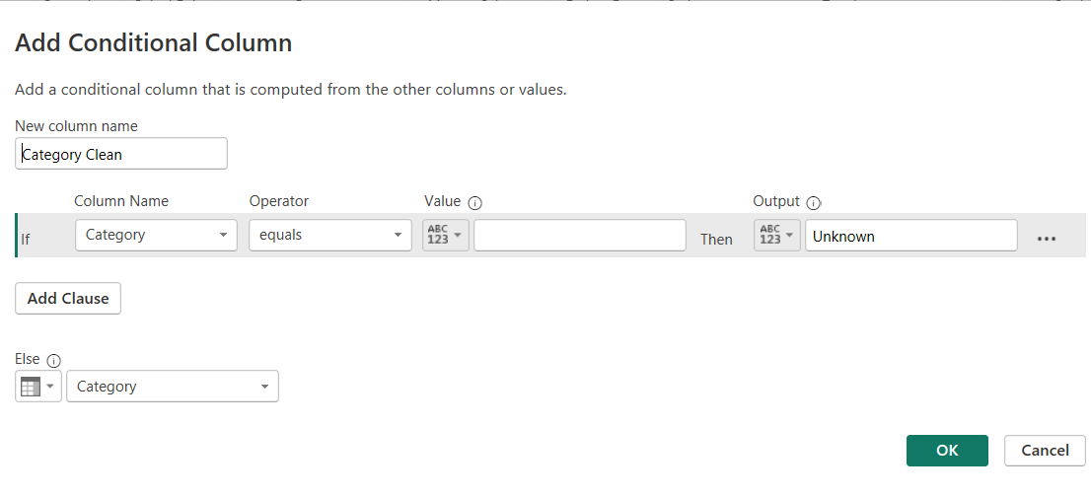
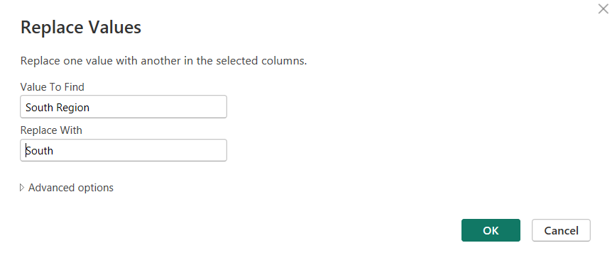
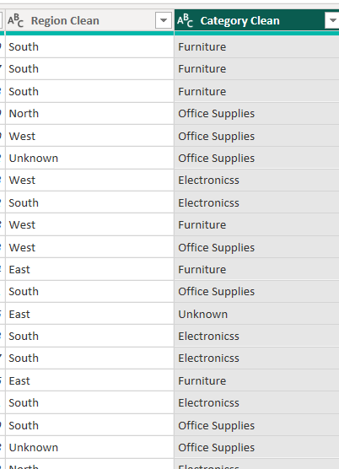
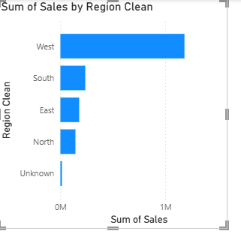
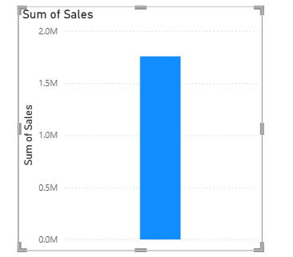
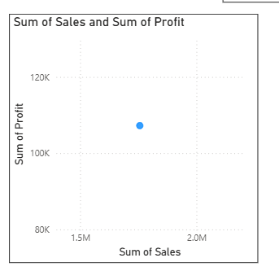

Dashboard :
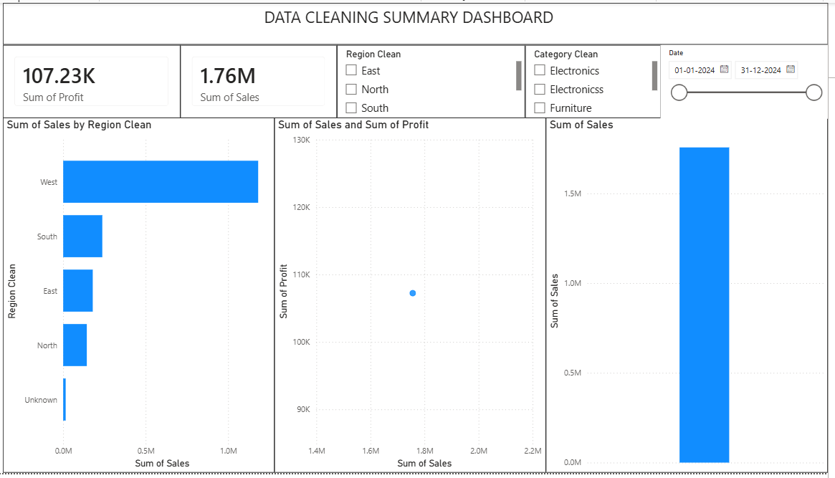

POST-LAB QUESTIONS
- What method did you use to replace missing values in numeric fields?

I replaced missing numeric values using the mean (average) value in Tableau and Power Query. This preserved the dataset while ensuring accurate calculations and visualizations.

- How were outliers handled in your dataset and what visual confirmed their correction?

Outliers were identified using summary statistics and visualizations, then corrected or removed where appropriate. A box plot and updated charts confirmed that the extreme values were handled successfully.

- What inconsistencies were detected in categorical values and how were they standardized?
Inconsistencies such as "south", "South Region", "OfficeSupply", and "Electronic" were detected. They were standardized to "South", "Office Supplies", and "Electronics" using the Replace Values transformation.

- Describe how calculated fields helped in resolving data issues.

Calculated fields were used to replace null values, calculate missing metrics, create new measures, and improve data consistency, resulting in more accurate analysis and visualizations.

- How did your dashboard demonstrate the effectiveness of the data cleaning process?

The dashboard displayed clean, consistent, and accurate visualizations without missing values or incorrect categories. Filters, charts, and KPIs produced reliable insights, demonstrating successful data cleaning and transformation.

RESULT:

The dataset was successfully cleaned and prepared for accurate analysis using Tableau and Power BI. Issues such as nulls, inconsistencies, and outliers were identified and resolved, improving data quality significantly.

ASSESSMENT
Description |  | Max Marks | Marks Awarded
Pre Lab Exercise |  | 5
In Lab Exercise |  | 10
Post Lab Exercise |  | 5
Viva |  | 10
 | Total | 30
 |  | Faculty Signature

